Connect to the VISCA interface of the camera through the USB TTL serial port, and Send the hexadecimal code to control the camera ZOOM

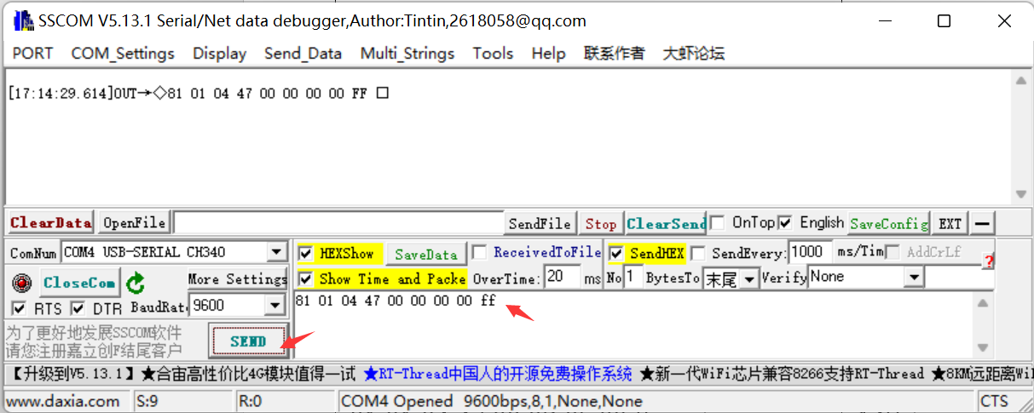
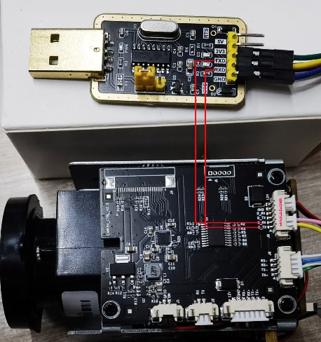

VISCA Hexadecimal | Optical ZOOM | VISCA Hexadecimal | Digital ZOOM
give an example:0x0000-0x04000  81 01 04 47 00 00 00 00 ff  81 01 04 47 00 06 00 00 ff  81 01 04 47 00 09 0b 00 ff  81 01 04 47 00 09 0F 00 ff  81 01 04 47 01 00 00 00 ff  81 01 04 47 01 03 00 00 ff  81 01 04 47 01 06 00 00 ff  81 01 04 47 01 09 00 00 ff  81 01 04 47 01 09 0F 00 ff  81 01 04 47 02 00 00 00 ff  81 01 04 47 02 02 00 00 ff  81 01 04 47 02 06 00 00 ff  81 01 04 47 02 09 00 00 ff  81 01 04 47 02 0B 0F 00 ff  81 01 04 47 02 0F 0F 00 ff  81 01 04 47 03 02 00 00 ff  81 01 04 47 03 02 0F 00 ff  81 01 04 47 03 04 0F 00 ff  81 01 04 47 03 07 00 00 ff  81 01 04 47 03 08 00 00 ff  81 01 04 47 03 0C 00 00 ff  81 01 04 47 03 0D 00 00 ff  81 01 04 47 03 0E 00 00 ff  81 01 04 47 03 0E 09 00 ff  81 01 04 47 03 0E 0A 00 ff  81 01 04 47 03 0E 0E 00 ff  81 01 04 47 03 0F 05 00 ff  81 01 04 47 03 0F 08 00 ff  81 01 04 47 03 0F 0F 00 ff  81 01 04 47 04 00 00 00 ff | 1X  2X  3X  4X  5X  6X  7X  8X  9X  10X  11X  12X  13X  14X  15X  16X  17X  18X  19X  20X  21X  22X  23X  24X  25X  26X  27X  28X  29X  30X | give an example:0x04000 - 0x040FF  81 01 04 47 04 00 00 03 ff  81 01 04 47 04 00 00 06 ff  81 01 04 47 04 00 00 0A ff  81 01 04 47 04 00 00 0C ff  81 01 04 47 04 00 00 0F ff  81 01 04 47 04 00 01 06 ff  81 01 04 47 04 00 01 0A ff  81 01 04 47 04 00 02 00 ff  81 01 04 47 04 00 03 00 ff  81 01 04 47 04 00 04 00 ff  81 01 04 47 04 00 05 00 ff  81 01 04 47 04 00 06 00 ff  81 01 04 47 04 00 07 00 ff  81 01 04 47 04 00 08 00 ff  81 01 04 47 04 00 09 00 ff  81 01 04 47 04 00 0A 00 ff  81 01 04 47 04 00 0B 00 ff  81 01 04 47 04 00 0C 00 ff  81 01 04 47 04 00 0D 00 ff  81 01 04 47 04 00 0E 00 ff  81 01 04 47 04 00 0F 00 ff  81 01 04 47 04 00 0F 0F ff | 33X  36X  39X  42X  45X  51X  57X  63X  72X  96X  114X  129X  147X  165X  180X  198X  216X  231X  249X  258X  282X  300X

